HOTEL RESERVATION SYSTEM
CSE241 Object-Oriented Computer Programming
Milestone 2

Submitted To
Dr. Mahmoud Ibrahim Khalil
Eng. Mario Remon

Team Members
Abdelrahman Mostafa Ibrahim | 25P0339
Eslam Ahmed Mohammed | 25P0310
Ahmed Ayman Ahmed Yousef | 25P0295
Kareem Waheed Mostafa | 25P0450

Table of Contents
1. Introduction
2. Project Overview
3. GUI Design and Implementation
4. Key Features
5. JavaFX Layouts and Navigation
6. FXML and MVC Structure
7. CSS Styling
8. Validation and Error Handling
9. Testing and Test Cases
10. Challenges and Solutions
11. Conclusion

1. Introduction
This report presents the implementation of Milestone 2 for the Desktop Hotel Reservation System project.
The goal of this milestone was to extend the backend system developed in Milestone 1 by integrating a complete graphical user interface using JavaFX.
The system was designed to provide an interactive and user-friendly experience for hotel guests, receptionists, and administrators.
The application follows object-oriented programming principles and uses JavaFX technologies such as FXML, CSS styling, and event handling.
2. Project Overview
The Hotel Reservation System is a desktop application developed using Java.
The system allows users to register, log in, browse available rooms, create reservations, manage bookings, and complete checkout operations.
The application supports different user roles:
• Guest
• Receptionist
• Administrator
The project combines backend logic with frontend GUI implementation to provide a fully functional hotel management experience.
3. GUI Design and Implementation
The graphical user interface was implemented entirely using JavaFX.
Several screens were designed to ensure smooth navigation and usability.
Implemented Screens:
• Login Screen
• Registration Screen
• Guest Dashboard
• Room Browsing Screen
• Reservation Management Screen
• Checkout and Payment Screen
• Admin Dashboard
• Receptionist Dashboard
Each screen was designed with a clean layout and organized controls such as buttons, labels, text fields, combo boxes, and tables.

4. Key Features
The system includes several important features:
• User Authentication:
Guests and staff members can securely log in using usernames and passwords.
• Room Browsing:
Users can browse available rooms and filter them based on room type, amenities, and price.
• Reservation Management:
Guests can create, view, and cancel reservations.
• Payment System:
The checkout system allows multiple payment methods including cash, credit card, and online payment.
• Admin Controls:
Administrators can manage rooms, room types, amenities, and reservations.
• Receptionist Controls:
Receptionists can perform check-in and check-out operations for guests.
5. JavaFX Layouts and Navigation
Different JavaFX layouts were used to organize the interface effectively:
• BorderPane
• VBox
• HBox
• GridPane
• StackPane
Scene switching was implemented to allow smooth navigation between screens.
Buttons and menu items were connected to event handlers to provide interactive functionality.
6. FXML and MVC Structure
FXML files were used to separate the interface design from application logic.
This improved maintainability and readability of the project.
The project follows the MVC (Model-View-Controller) design pattern:
• Model:
Contains backend classes such as Guest, Room, Reservation, and Invoice.
• View:
Contains FXML files and CSS styling.
• Controller:
Handles user interaction and communication between the GUI and backend.

7. CSS Styling
CSS stylesheets were applied to provide a professional and consistent appearance across all screens.
The styling included:
• Button colors and hover effects
• Font customization
• Background colors
• Table formatting
• Padding and spacing
• Responsive layout adjustments
The use of CSS improved the overall user experience and application appearance.
8. Validation and Error Handling
Input validation was implemented throughout the application to prevent invalid data entry.
Examples of validation:
• Empty username or password fields
• Invalid date selection
• Negative payment amounts
• Room availability conflicts
The application displays alerts and warning dialogs whenever invalid operations occur.
Custom exceptions were also used to improve error handling.
9. Testing and Test Cases
Several test cases were performed to verify system correctness and reliability.
Valid Test Cases:
• Successful login
• Successful reservation creation
• Successful payment operation
• Admin room management operations
Invalid Test Cases:
• Invalid login credentials
• Attempting to reserve unavailable rooms
• Empty registration fields
• Invalid payment information
The application handled invalid operations correctly and displayed appropriate feedback messages.
10. Challenges and Solutions
During development, several challenges were encountered:
• Managing scene switching between multiple screens
• Maintaining synchronization between GUI and backend logic
• Preventing UI freezing during background operations
Solutions included:
• Using MVC architecture
• Implementing JavaFX Task for background operations
• Organizing project files into structured packages

11. Conclusion
The Hotel Reservation System successfully achieved the objectives of Milestone 2.
The project integrates a functional JavaFX GUI with backend logic.
The application demonstrates strong object-oriented programming practices, clean interface design, and efficient system functionality.
This project provided valuable experience in Java desktop application development, JavaFX design, and software engineering principles.
Future improvements may include:
• Database integration
• Advanced reporting features
• Online booking synchronization
• Enhanced security features
• Mobile application support

- Team Contributions
Each team member contributed to different parts of the project including backend development, GUI implementation, testing, networking, and documentation.
Team Member | contribution
Abdelrahman Mostafa | (Guest, Reservation, part of Main,exception, part of GuestDashboard.fxml ,part of GuestDashboardController.java)
Eslam Ahmed | (invoice class , interfaces,enums ,documentation, Login.fxml ,LoginController.java , HotelFXApp.java)
Ahmed Ayman | (admin staff receptionist ,part of main,exception , StaffDashboard.fxml , StaffDashboardController.java , style.css)
Kareem Waheed | (uml database amenity room roomtype , part of GuestDashboard.fxml , part of GuestDashboardController.java )

- GUI Screenshots
- Test Case – Guest Login : -The user opens the application, selects the Guest role, enters the username Kareem and the password Kareem@123, then clicks the Login button. The expected result is that the system authenticates the guest successfully and opens the Guest Dashboard, where the user can view profile information, account balance, reservations, available rooms, and payment options
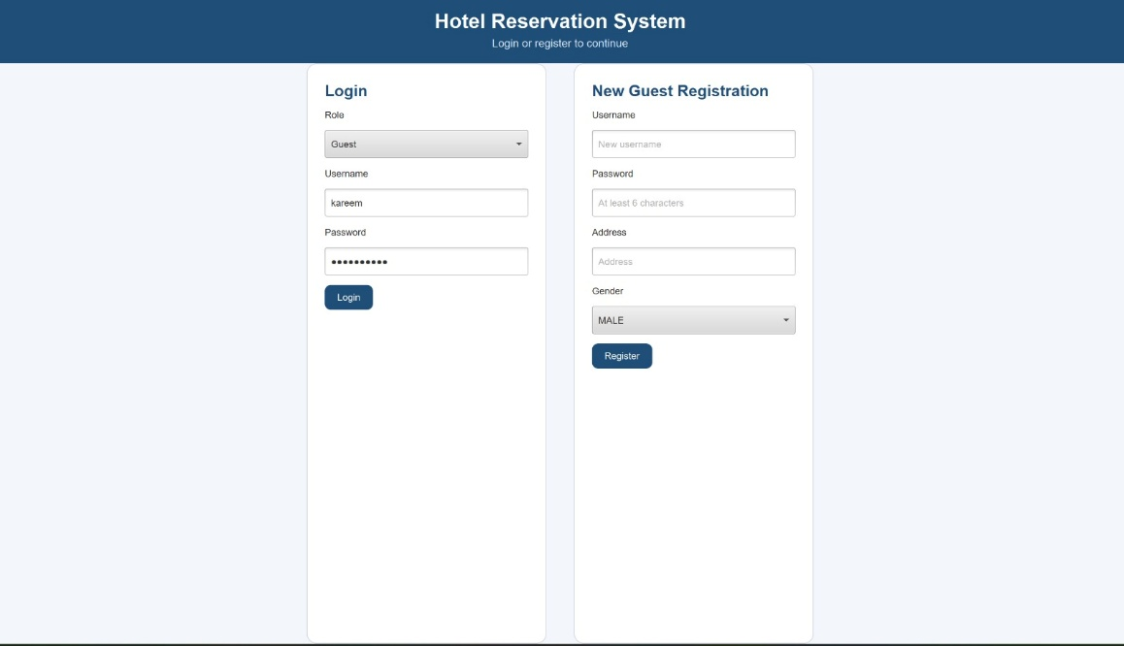

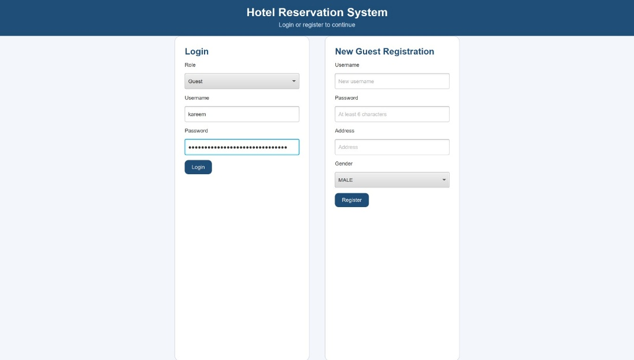
- Test Case – Invalid Guest Login:- The user opens the application, selects the Guest role, enters the username Kareem and an incorrect password, then clicks the Login button.The expected result is that the system rejects the login attempt, displays an error message indicating invalid username or password, and prevents access to the Guest Dashboard .
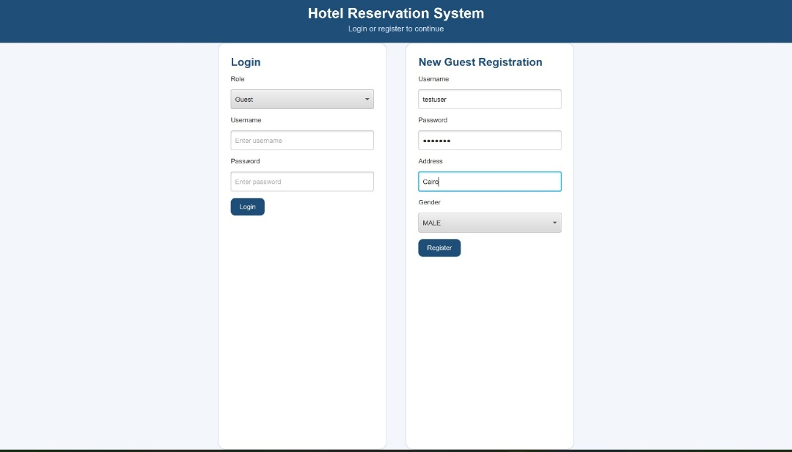
- Test Case – Guest Registration: -The user opens the application, enters the username Kareem , password Kareem@123, address Cairo, Egypt, selects the gender MALE, and clicks the Register button. The expected result is that the system validates the entered information, creates a new guest account successfully, displays a registration success message, and allows the guest to log in using the new credentials.

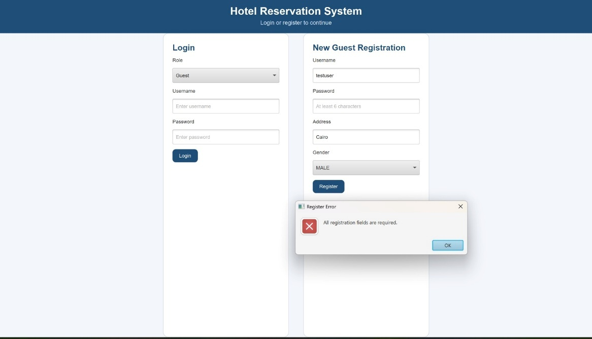
- Test Case – Invalid Guest Registration: -The user opens the application, enters an invalid or incomplete registration form such as an empty username or a password shorter than 6 characters, then clicks the Register button. The expected result is that the system rejects the registration attempt, displays appropriate validation error messages, and prevents creation of the guest account until valid information is entered.

- Test Case – Room Browsing: -The user logs into the system successfully and opens the Room Browsing screen to view available hotel rooms with their details such as room type, price, and amenities. The expected result is that the system displays all available rooms correctly and allows the user to browse and filter rooms based on their preferences.
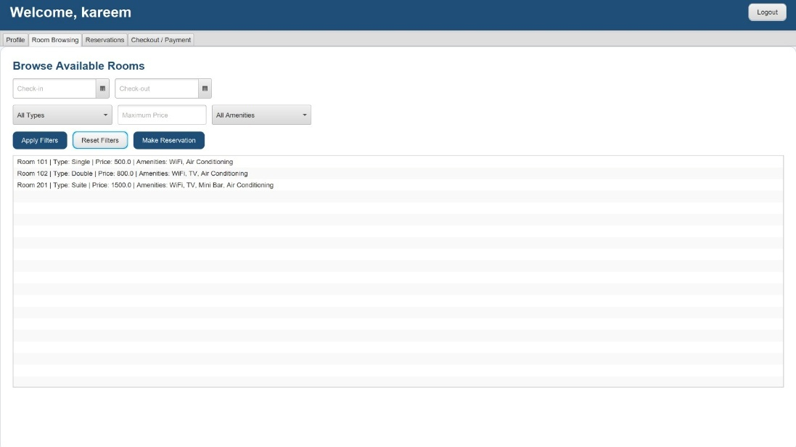

- Test Case – Room Filtering by Type: -The user opens the Room Browsing screen and selects a specific room type filter such as Single, Double, or Suite to view matching available rooms. The expected result is that the system displays only rooms matching the selected type and updates the room list correctly without affecting the application performance.
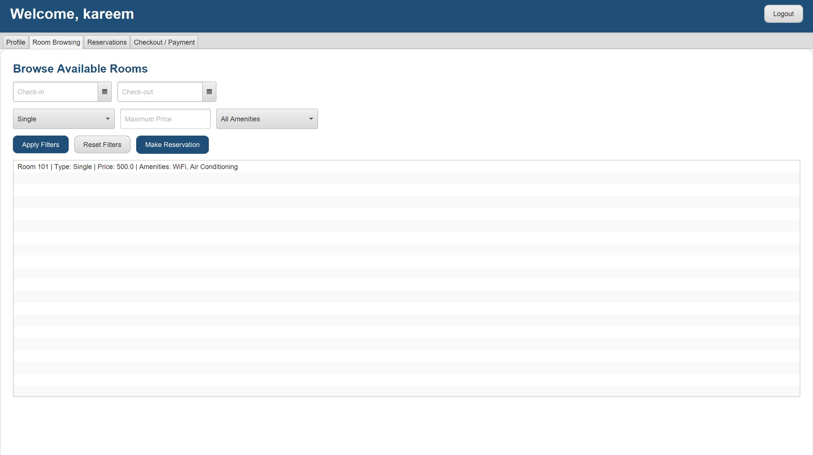
- Test Case – Room Filtering by Price: -The user opens the Room Browsing screen and applies a price filter to display rooms within a specific price range. The expected result is that the system displays only rooms matching the selected price criteria and updates the filtered room list correctly.

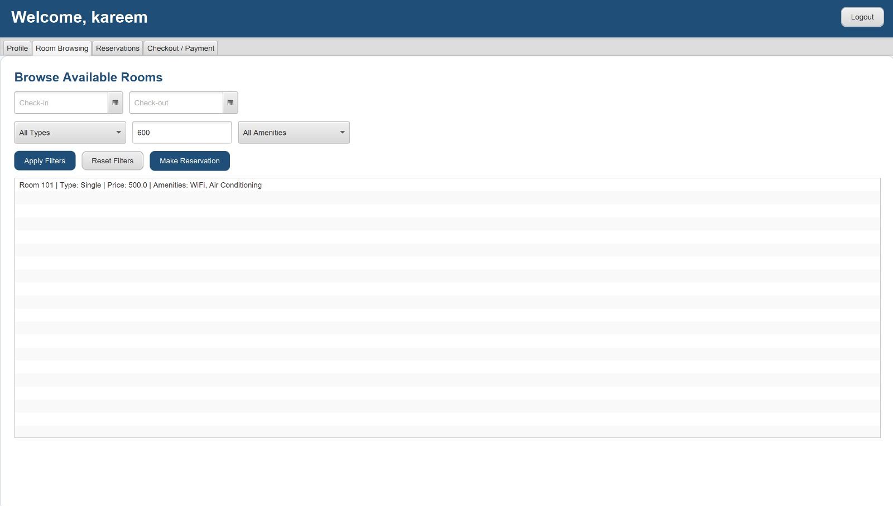

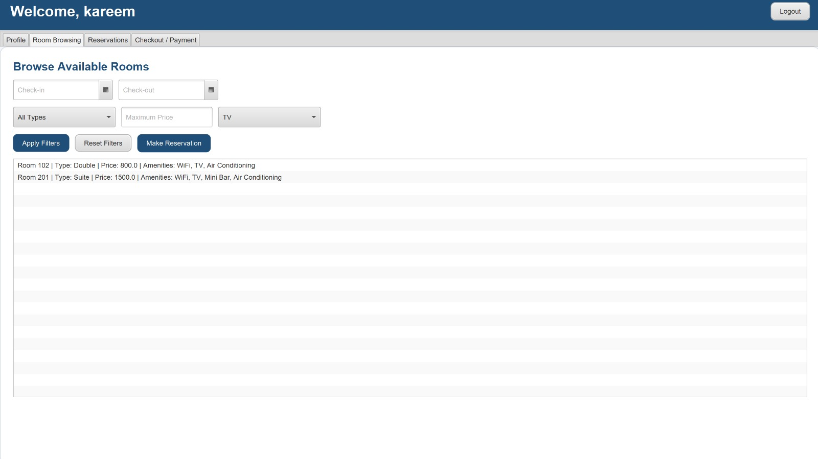
- Test Case – Room Filtering by Amenity: -The user opens the Room Browsing screen and selects a specific amenity filter such as WiFi, TV, or Mini-bar to search for matching rooms. The expected result is that the system displays only rooms containing the selected amenity and updates the room list accurately.

- Test Case – Make Reservation: -The user logs into the system using the username Kareem, browses the available rooms, selects Room 102, enters valid check-in and check-out dates, and clicks the Make Reservation button.The expected result is that the system creates the reservation successfully, displays a confirmation message with status PENDING, and updates the reservation list and room availability accordingly.
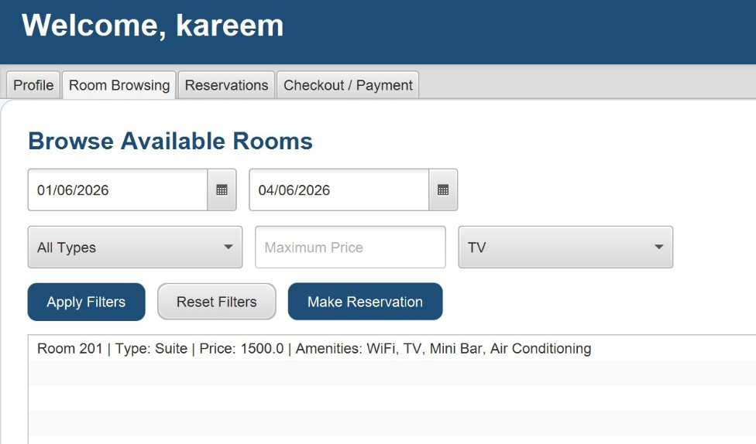
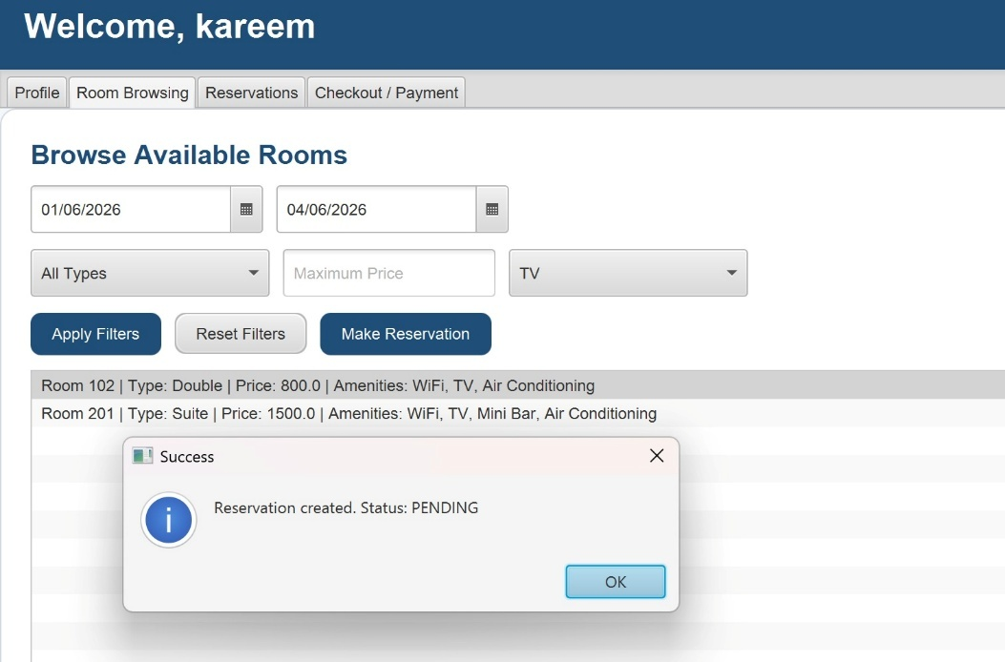
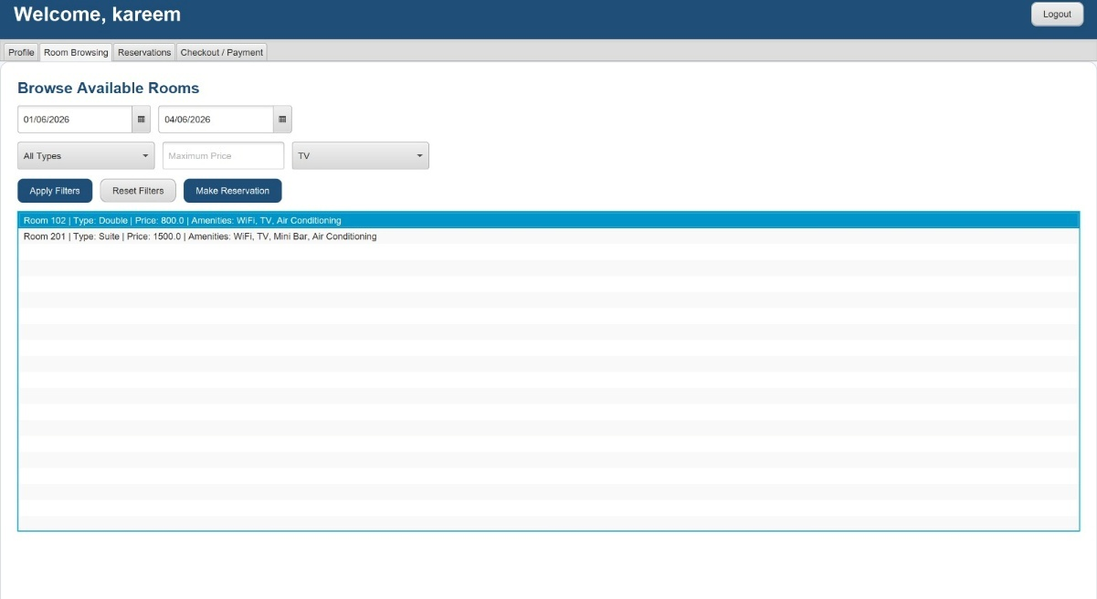
- Test Case – Cancel Reservation: -The user logs into the system, opens the Reservations screen, selects an existing reservation, and clicks the Cancel Selected button. The expected result is that the system cancels the selected reservation successfully, updates the reservation status, and refreshes the reservation list accordingly.

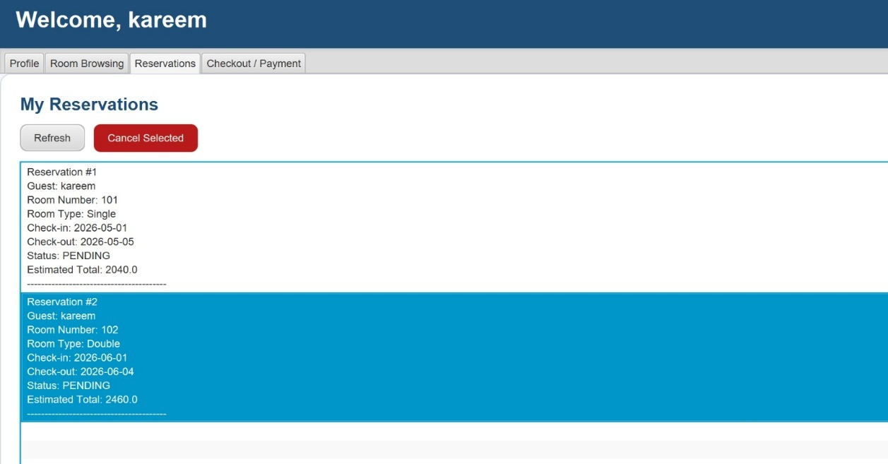

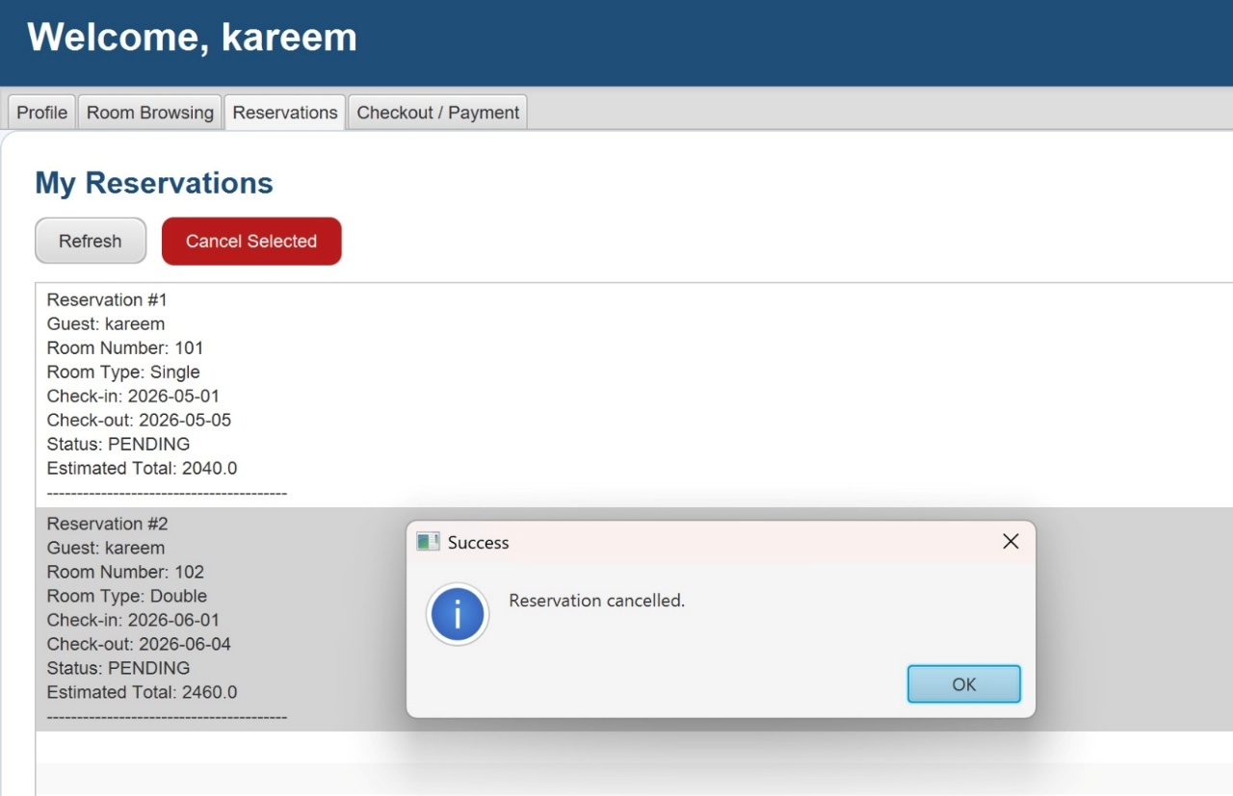

- Test Case – Checkout and Payment: -The user logs into the system, opens the Checkout / Payment screen, selects a pending invoice, enters the payment amount 2040, chooses the payment method CASH, and clicks the Pay Selected Invoice button. The expected result is that the system processes the payment successfully, updates the invoice status to paid, and displays a confirmation message for the completed transaction.

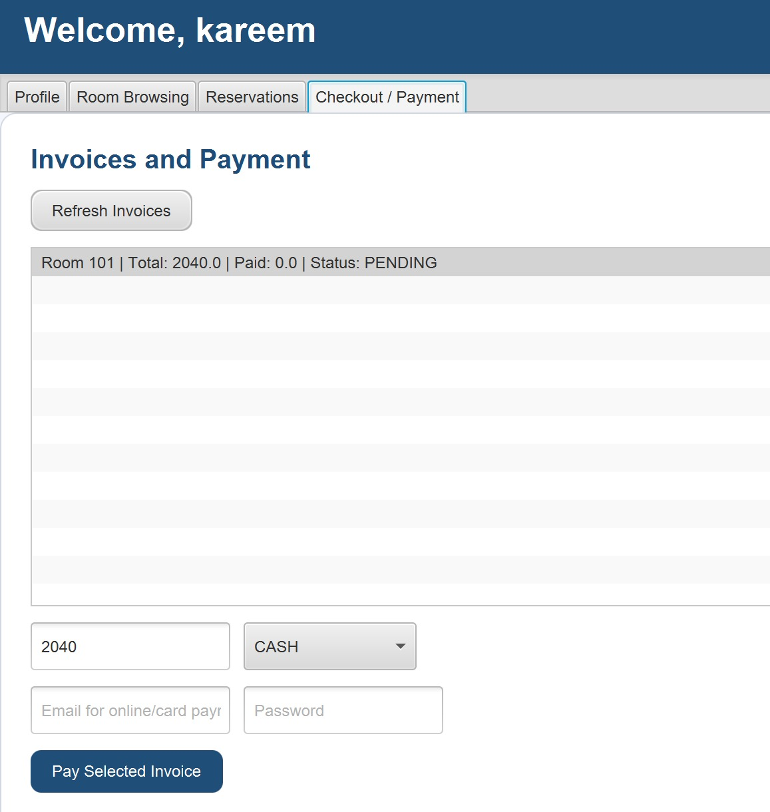

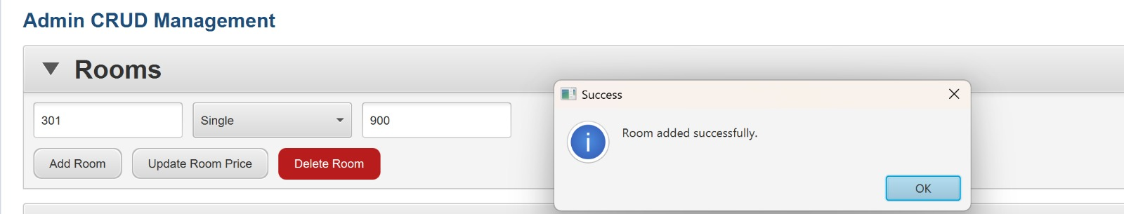
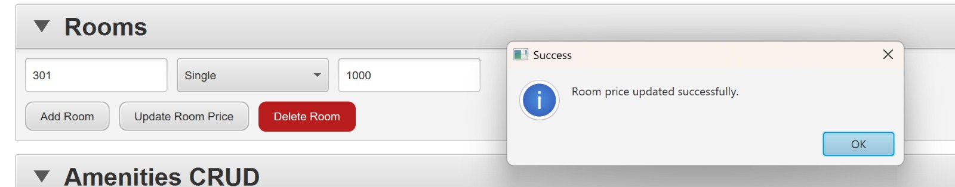
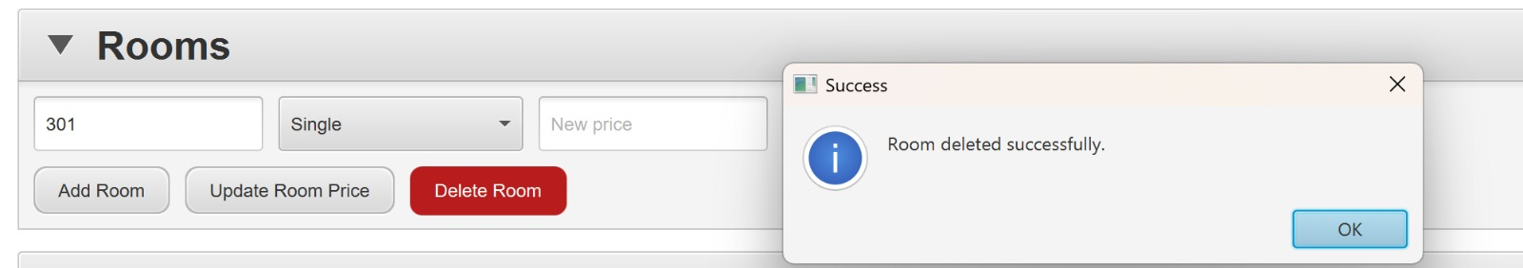
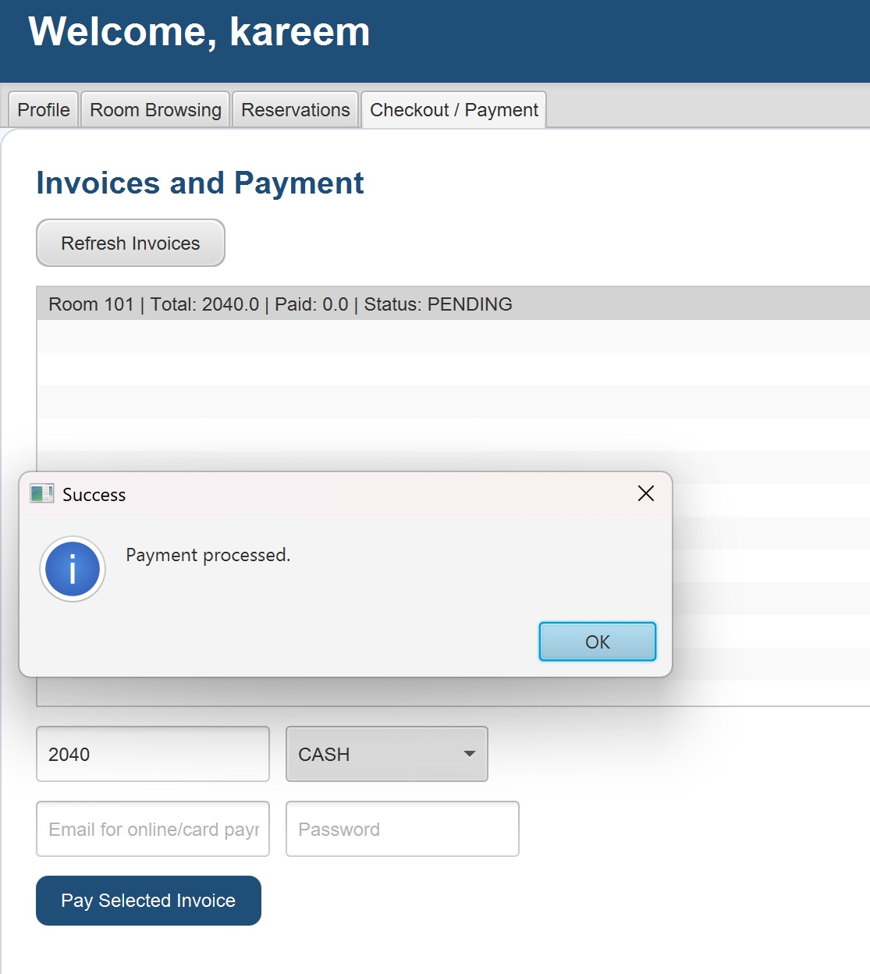
- Test Case – Admin Room CRUD Operations: -The admin opens the Admin CRUD Management screen, enters the room number 301, selects the room type Single, enters a room price, and performs room management operations including adding a new room, updating the room price, and deleting the room. The expected result is that the system executes each CRUD operation successfully, displays appropriate success messages such as “Room added successfully”, “Room price updated successfully”, and “Room deleted successfully”, and updates the room data accordingly.

- Test Case – Room Type CRUD Operations: -The admin opens the Room Types CRUD section, enters the room type name Deluxe with price 1200, and performs room type management operations including adding a new room type, updating the room type from Deluxe to Premium, and deleting the room type Premium. The expected result is that the system completes each CRUD operation successfully, displays confirmation messages such as “Room type added successfully”, “Room type updated successfully”, and “Room type deleted successfully”, and updates the room type data accordingly.
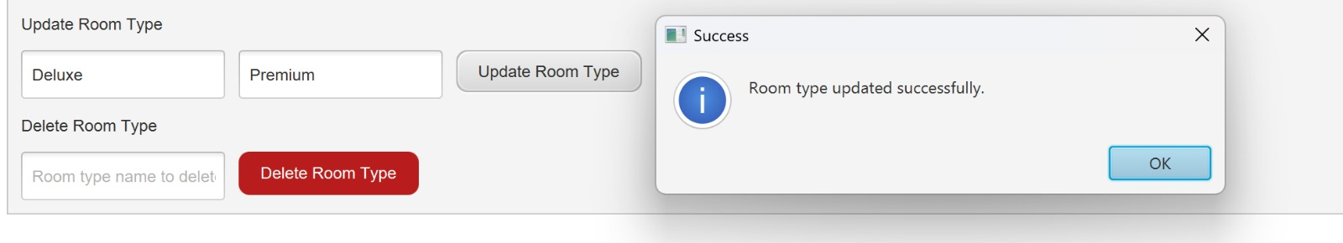
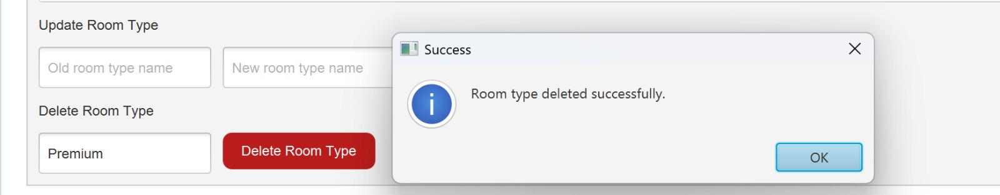
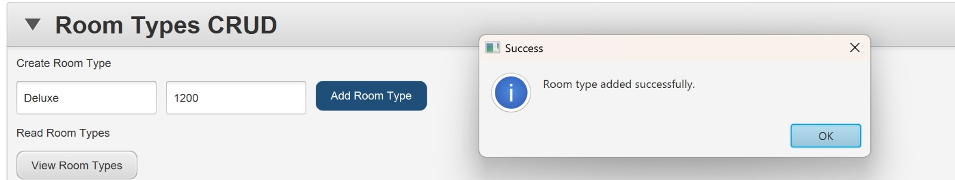

- Test Case – Receptionist Actions: -The receptionist logs into the system using the username reception1, views guests, rooms, and reservations, then performs reservation management actions including confirming reservations, checking in guests, and checking out guests. The receptionist also attempts an invalid operation by trying to check in or confirm a cancelled reservation. The expected result is that the system processes valid receptionist actions successfully by displaying confirmation messages such as “Reservation confirmed”, “Guest checked in”, and “Check-out completed”, while invalid actions display appropriate error messages such as “Reservation must be CONFIRMED first” or “Cannot confirm reservation”.

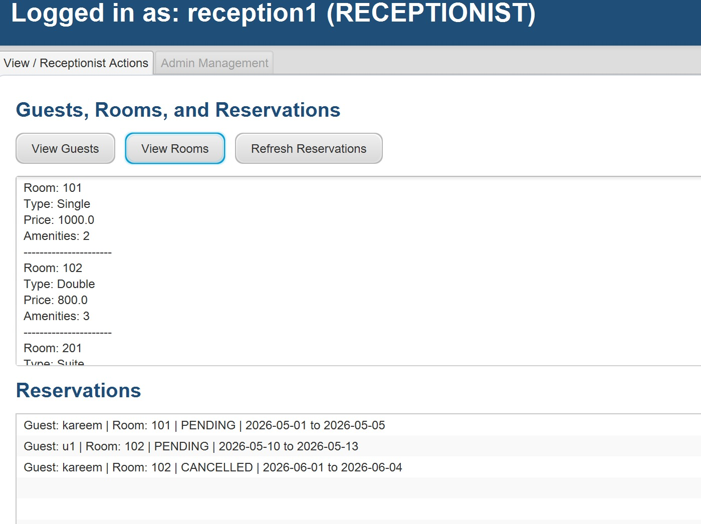
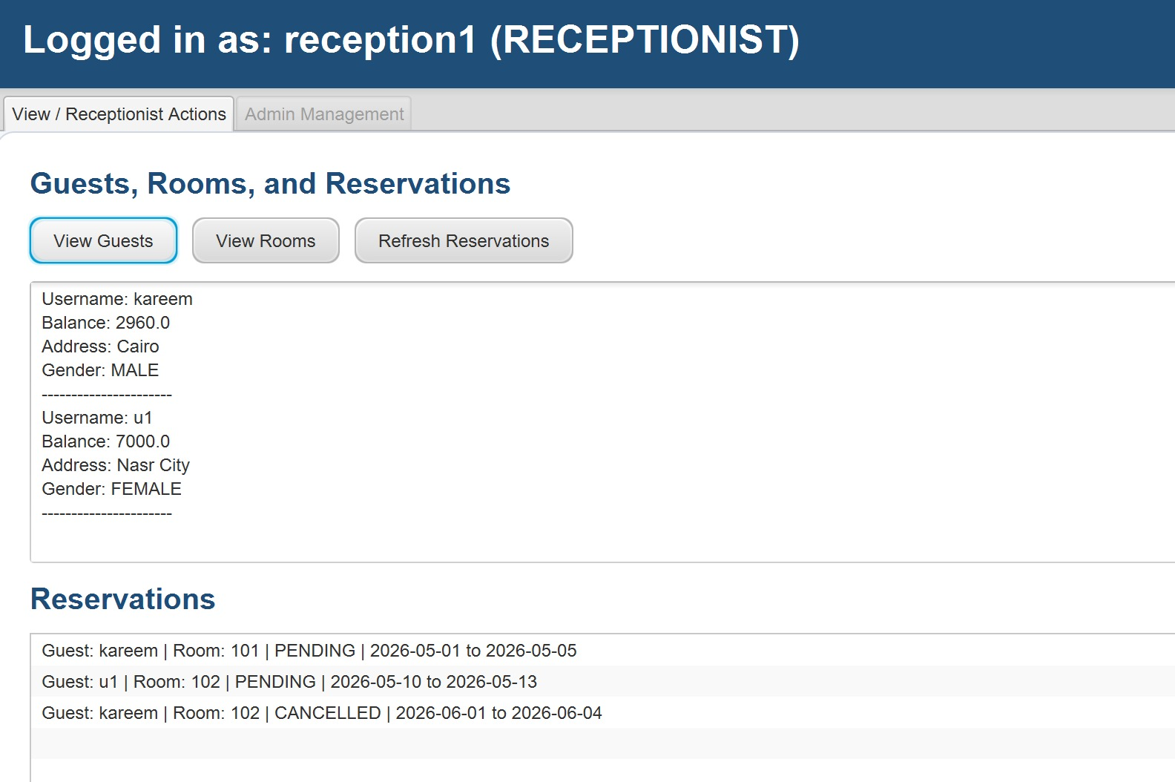

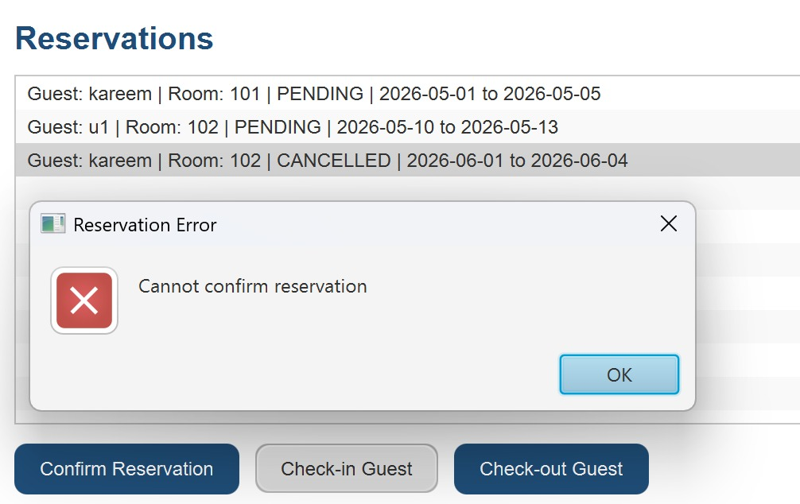

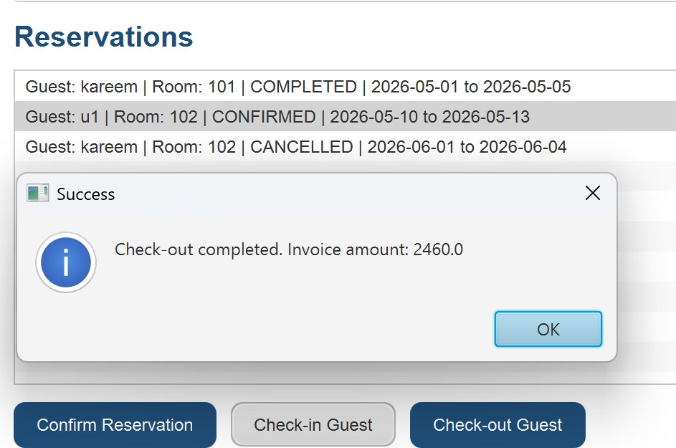

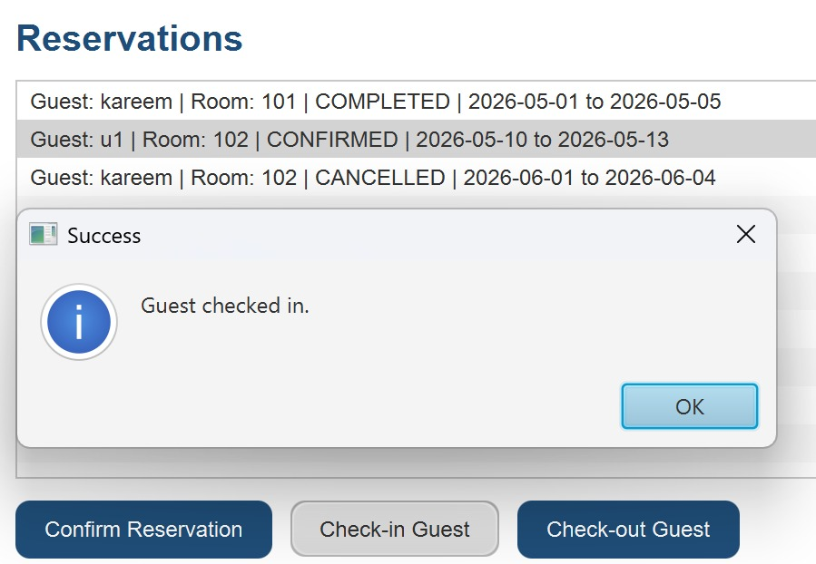

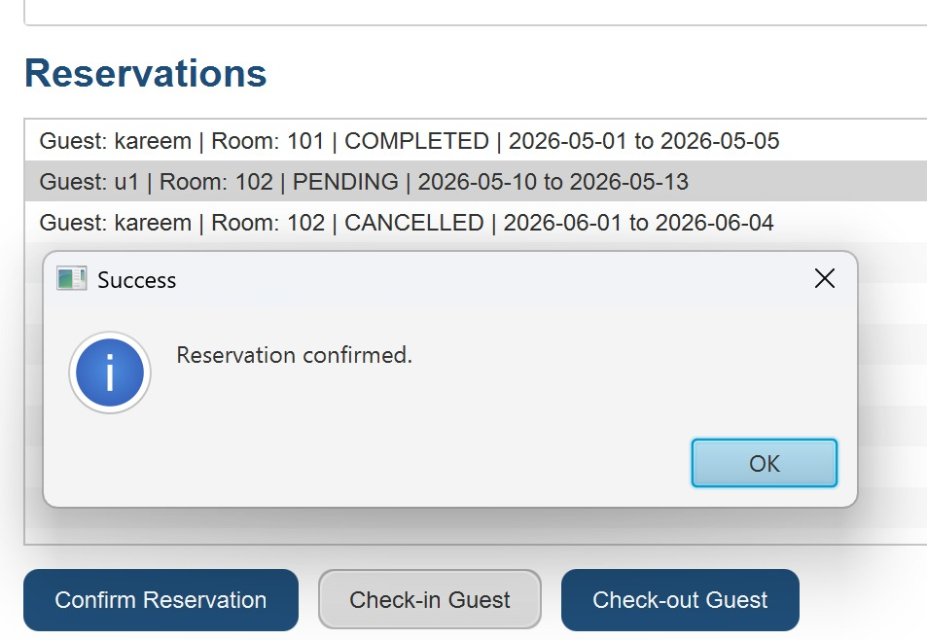
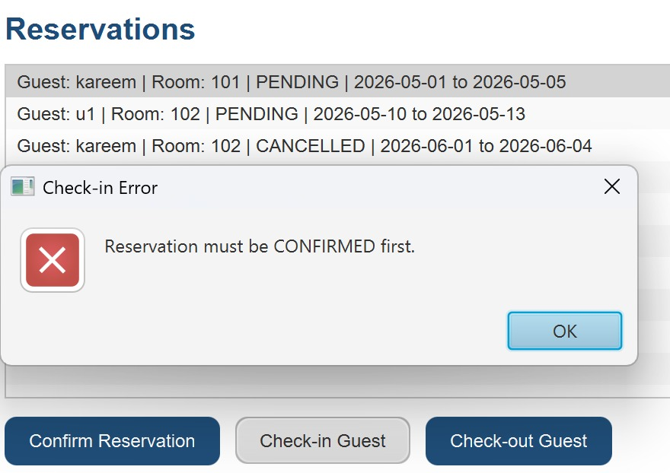
Project Demo Video
The following YouTube video demonstrates the functionality and features of the Hotel Reservation System, including the JavaFX graphical user interface, room reservation process, payment system, receptionist actions, and admin CRUD operations :
https://youtu.be/_AnCpmcxBZs?si=hrMrg34q0TyxhD9p

